### User Side Epic (Customer Journey for Ordering)

As a Customer,

I want to place orders with payment & coupon flexibility,

so that I have a seamless ordering experience.

**To-Be Process Flow**

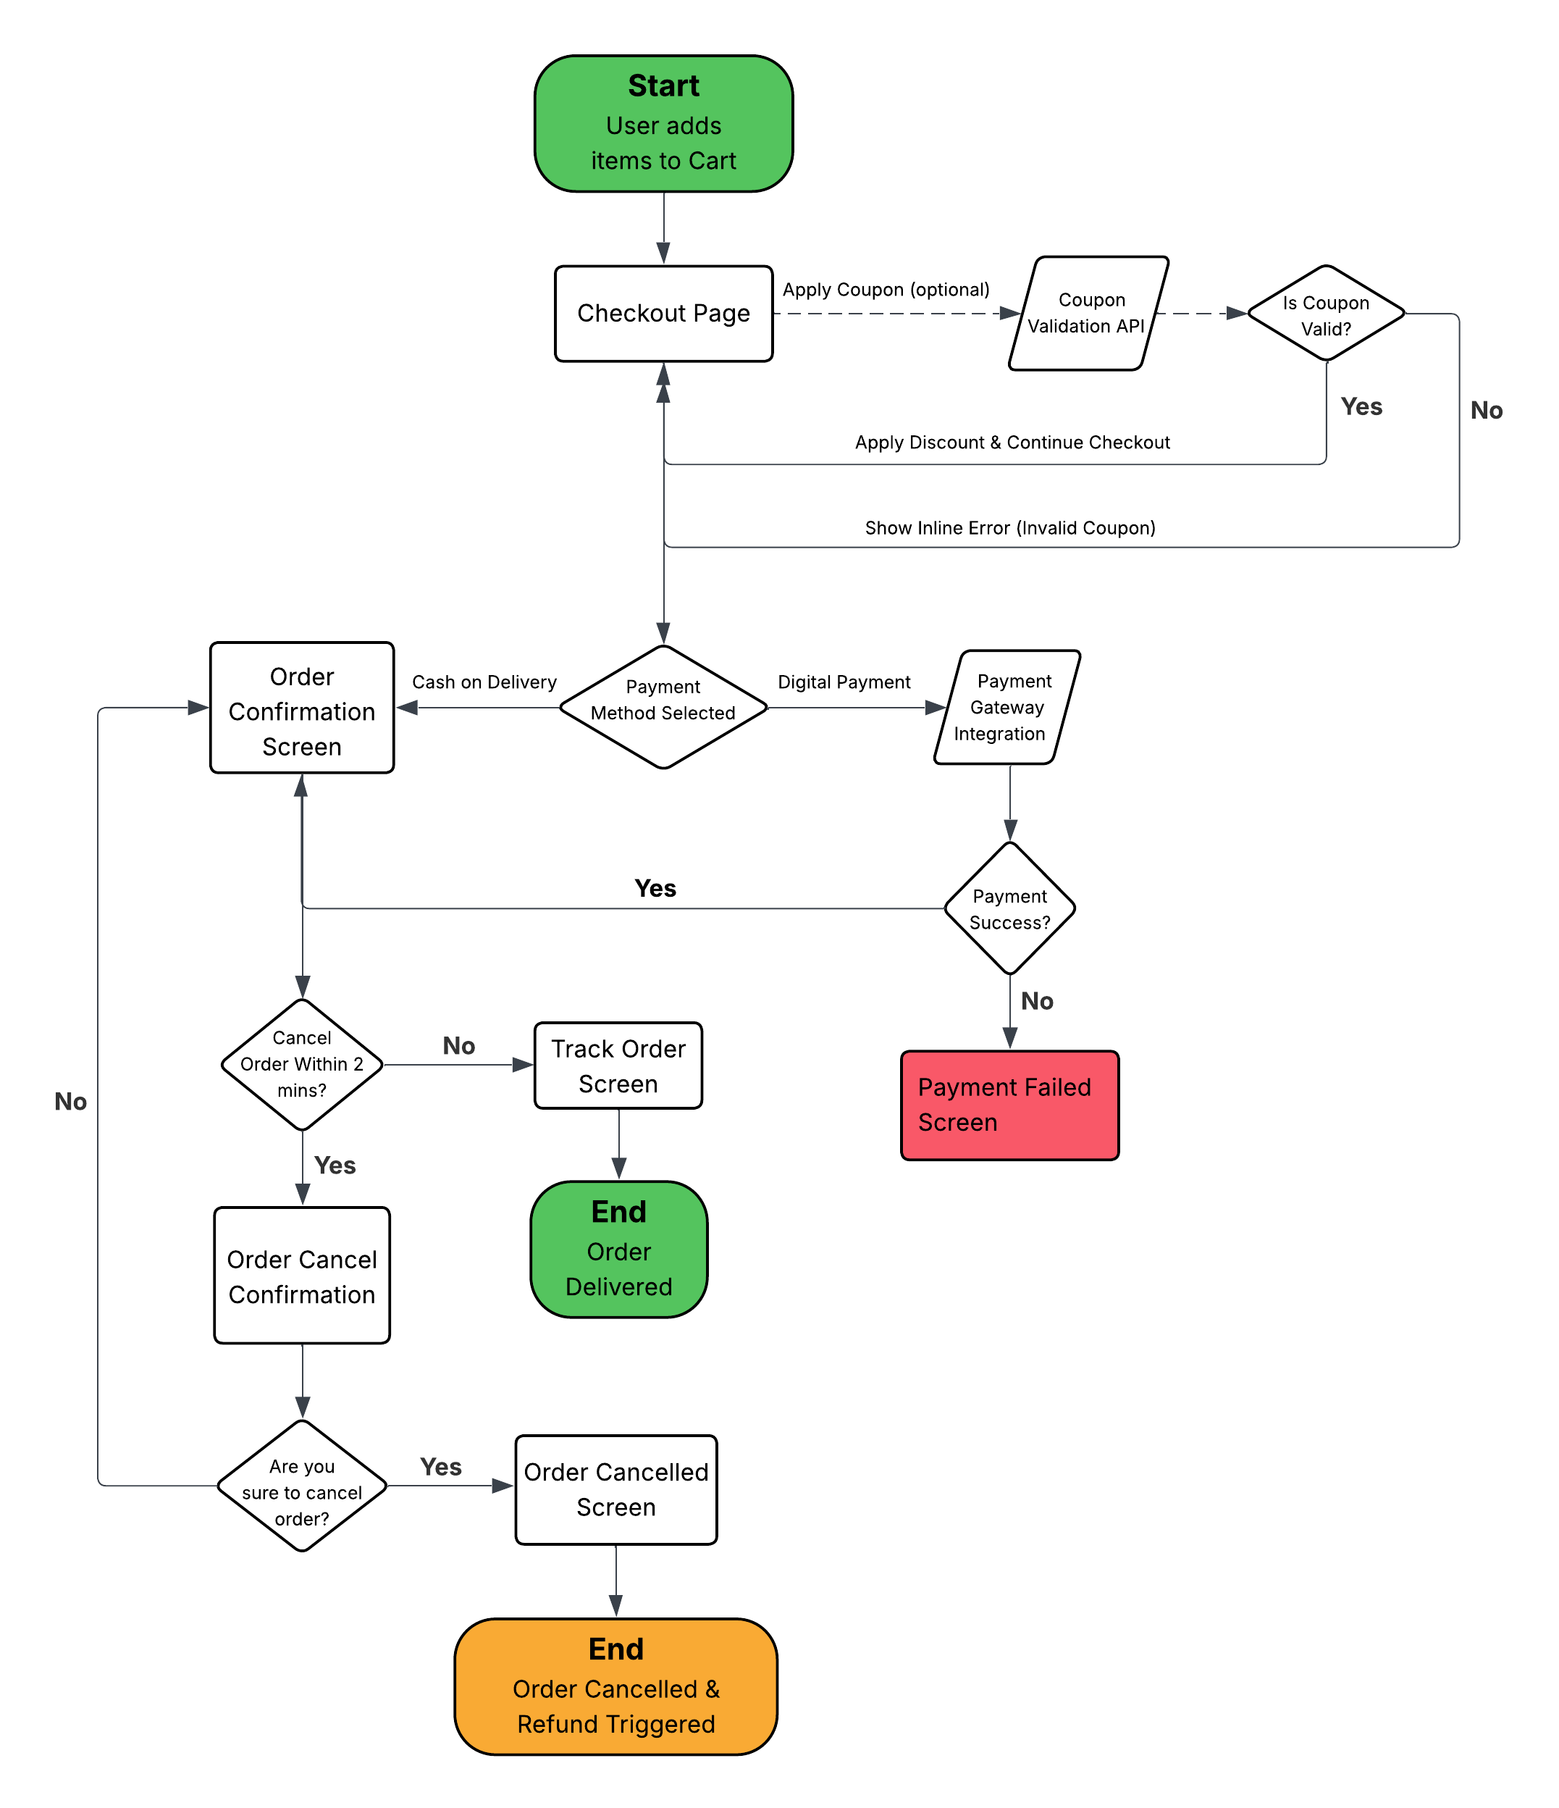

**US-01: Apply Coupon Code during Checkout**

|  |  |
| --- | --- |
| **As a** | customer |
| **I want** | to apply a coupon code during checkout |
| **So that** | I can avail discounts on my order. |
| **Acceptance Criteria** | 1. User lands on the Checkout Page after adding items to the cart. 2. System displays a "Have a Coupon Code?" text input field and an APPLY button. (Refer Appendix 1) 3. User enters a coupon code into the text field. 4. User clicks the APPLY button. 5. System sends the entered coupon code to the backend Coupon Validation API. 6. If the coupon code is valid:   a. System applies the discount to the Total Payable Amount.  b. A success message is displayed near the coupon field.   1. If the coupon code is invalid or expired: System displays an error message near the coupon field. 2. Only one coupon can be applied per order. 3. Entering a new coupon code will override the previous one. |

**Appendix 1**

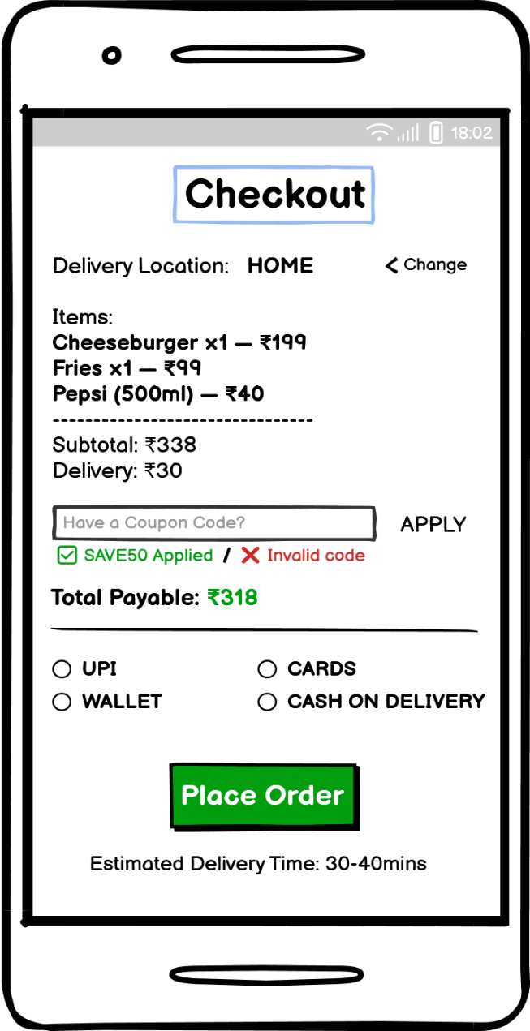

|  |  |  |  |  |  |  |  |
| --- | --- | --- | --- | --- | --- | --- | --- |
| **Sr. No.** | **Field Name** | **Field Type** | **Content** | **Required Field?** | **Min. Char.** | **Max Char.** | **Notes** |
| 1 | Coupon Code Field | Text Input | Alpha-Numeric | No | 3 | 30 | Optional field for applying promo codes |
| 2 | Apply Button | Command Button | APPLY | No | N/A | N/A | Validates and applies entered coupon code |
| 3 | Coupon Status Message | Text Label | ✅ SAVE50 Applied / ❌ Invalid code | N/A | N/A | N/A | Shows result of coupon validation |
| 4 | Total Payable Amount | Text Label | Total Payable: ₹318 | N/A | N/A | N/A | Displays total amount payable after discounts |

**‘Apply Coupon’ data validations**

On click of the **‘Apply’ Command Button**, the system shall perform the following validations on the entered coupon code and related parameters:

1. The coupon code input must not be blank when Apply button is clicked.
2. The coupon code must contain only alphabets and numbers. Special characters are not allowed.
3. The entered coupon code must have at least 3 characters to be considered valid.
4. The coupon code must exist in the coupon database and must be in Active status.
5. The current system date must fall within the coupon's Valid From and Valid To dates.
6. The user must meet the eligibility criteria defined for the coupon (e.g., first-time user, targeted campaign).
7. If the coupon has a Min Order Value condition, the cart total must meet or exceed it.
8. The number of times the user has redeemed this coupon must not exceed the defined Max Usage per User.
9. The system shall ensure only one active coupon code is applied per order. Applying a new code overrides any previously applied coupon.

**Error Messages:**

|  |  |
| --- | --- |
| **Failed Validation** | **Error Message Displayed** |
| Coupon code field is empty | Please enter a coupon code to apply. |
| Coupon code is invalid format (special characters, less than 3 chars) | Invalid coupon code format. |
| Coupon does not exist or expired | The coupon code entered is invalid or expired. |
| Coupon is not applicable on current cart/order | This coupon is not applicable for your order. |
| Coupon usage limit exceeded by the user | You have already used this coupon. |
| Order value is below minimum required for coupon | Add items worth ₹X more to use this coupon. |
| Multiple coupons entered | Only one coupon can be applied per order. |
| Coupon code field is empty | Please enter a coupon code to apply. |

**US-02: Select Preferred Payment Method**

|  |  |
| --- | --- |
| **As a** | customer |
| **I want** | to select my payment method (UPI, Card, Wallet, COD) during checkout |
| **So that** | I can complete payment as per my preference. |
| **Acceptance Criteria** | 1. User lands on the Checkout Page with items in the cart. 2. System displays available payment options: UPI, Cards, Wallet, Cash on Delivery. (Refer Appendix 2) 3. User selects one payment method by tapping on the corresponding radio button (Selected radio button gets highlighted as active). 4. User clicks on the "Place Order" button. 5. If a digital payment option is selected (UPI/Card/Wallet):   a. System initiates payment flow through integrated Payment Gateway SDK.  b. On successful payment, user is navigated to the Order Confirmation Screen. (Refer Appendix 3)   1. If Cash on Delivery is selected: System confirms order and navigates directly to Order Confirmation Screen. 2. Selected payment method is displayed in the Order Confirmation Summary. |

**Appendix 2**



|  |  |  |  |  |  |  |  |
| --- | --- | --- | --- | --- | --- | --- | --- |
| **Sr. No.** | **Field Name** | **Field Type** | **Content** | **Required Field?** | **Min. Char.** | **Max Char.** | **Notes** |
| 1 | Payment Method Options | Radio Buttons | UPI, Wallet, Cards, Cash on Delivery | Yes | N/A | N/A | User must select one option for placing the order |
| 2 | Place Order Button | Command Button | Place Order | Yes | N/A | N/A | Confirms the order and proceeds to payment or confirmation screen |

**US-03: Cancel Order within 2 Minutes**

|  |  |
| --- | --- |
| **As a** | customer |
| **I want** | the ability to cancel my order within a 2-minute window after placing it |
| **So that** | I can avoid receiving orders placed by mistake or orders that I no longer want. |
| **Acceptance Criteria** | |  | | --- | | 1. After successfully placing an order, the user is navigated to the **Order Confirmation Screen**. (Refer Appendix 3) 2. System displays a **Cancel Order Button** along with a **2-minute countdown timer**. 3. A **visual progress bar** under the timer indicates the time left to cancel the order. 4. If the user clicks **“Cancel Order”** within the active timer window:   a. System asks for a confirmation prompt before cancelling the order. (Refer Appendix 4)  b. On confirmation, the order is cancelled, and the user is navigated to the **Order Cancelled Screen**. (Refer Appendix 5)  c. A success message is displayed indicating the order was cancelled.   1. If the timer expires (2 minutes passed), the **Cancel Order Button is disabled**. 2. Once cancelled, the backend system should trigger the **Refund process (if prepaid order)**. 3. User should still have the option to **Track Order** for other status updates. | |

**Appendix 3**

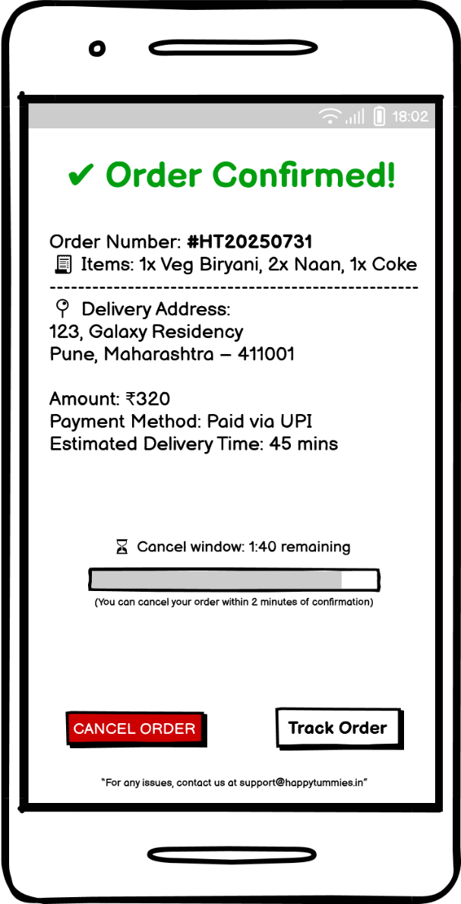

|  |  |  |  |  |  |  |  |
| --- | --- | --- | --- | --- | --- | --- | --- |
| **Sr. No.** | **Field Name** | **Field Type** | **Content** | **Required Field?** | **Min. Char.** | **Max Char.** | **Notes** |
| 1 | Cancel Window Timer | Countdown Label | Cancel window: 1:40 remaining | N/A | N/A | N/A | Shows time left to cancel order (within 2 minutes from order confirmation) |
| 2 | Cancel Timer Progress Bar | Progress Indicator | [Visual progress bar] | N/A | N/A | N/A | Visual representation of time left to cancel the order |
| 3 | Cancel Order Button | Command Button | CANCEL ORDER | No | N/A | N/A | Navigates user to ‘Order Cancel Confirmation’ page (Enabled only while cancel window is active) |

**Appendix 4**

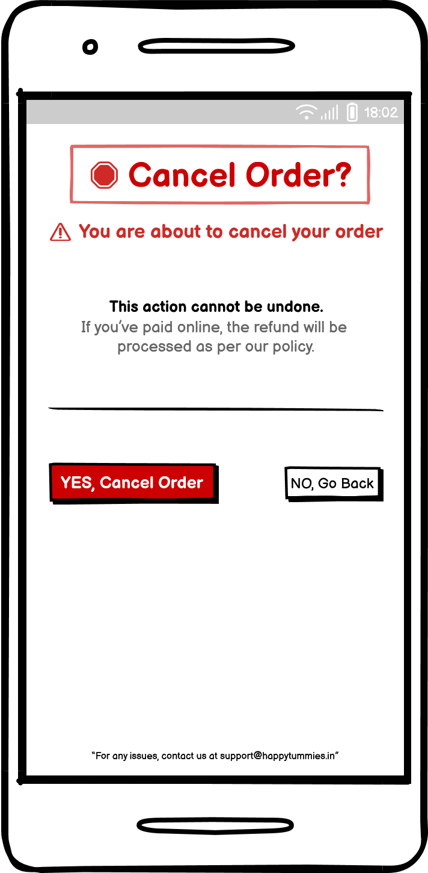

|  |  |  |  |  |  |  |  |
| --- | --- | --- | --- | --- | --- | --- | --- |
| **Sr. No.** | **Field Name** | **Field Type** | **Content** | **Required Field?** | **Min. Char.** | **Max Char.** | **Notes** |
| 1 | Page Title | Label / Heading | 🛑 Cancel Order? | N/A | N/A | N/A | Heading displayed at the top in red and bold |
| 2 | Warning Message | Text Label | ⚠️ You are about to cancel your order | N/A | N/A | N/A | Warning message shown in red |
| 3 | Info Message | Text Label | This action cannot be undone. | N/A | N/A | N/A | Displayed in bold black text |
| 4 | Refund Policy Text | Text Label | If you’ve paid online, the refund will be processed as per our policy. | N/A | N/A | N/A | Shown in grey below the main warning |
| 5 | Horizontal Divider | Visual Divider | [Line] | N/A | N/A | N/A | Separates message content from action buttons |
| 6 | Cancel Order Button | Command Button | YES, Cancel Order | No | N/A | N/A | In red; confirms cancellation and navigates user to ‘Order Cancelled’ page |
| 7 | Go Back Button | Command Button | NO, Go Back | No | N/A | N/A | In grey; returns to previous screen |
| 8 | Support Message | Footer Text | “For any issues, contact us at support@happytummies.in” | N/A | N/A | N/A | Static footer message with contact email for support |

**Appendix 5**

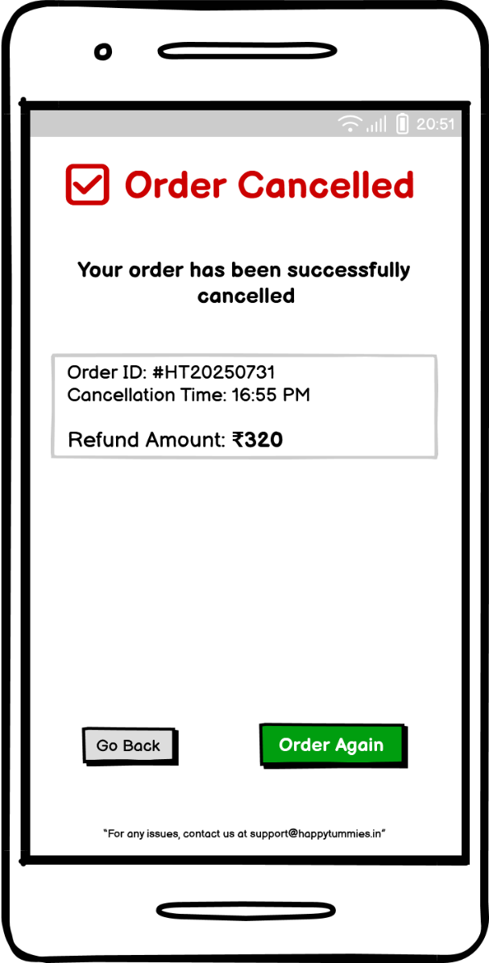

|  |  |  |  |  |  |  |  |
| --- | --- | --- | --- | --- | --- | --- | --- |
| **Sr. No.** | **Field Name** | **Field Type** | **Content** | **Required Field?** | **Min. Char.** | **Max Char.** | **Notes** |
| 1 | Cancellation Message | Label / Heading | ✅ Order Cancelled | N/A | N/A | N/A | Displayed at the top in red to confirm successful cancellation |
| 2 | Subheading Text | Text Label | Your order has been successfully cancelled | N/A | N/A | N/A | Short status message below the heading |
| 3 | Order Details Box | Container Group | Order ID: #HT20250731  Cancellation Time: 16:55 PM  Refund Amount: ₹320 | N/A | N/A | N/A | Grey-shaded card showing order ID, cancellation time, and refund amount (in bold) |
| 4 | Go Back Button | Command Button | Go Back | No | N/A | N/A | Navigates user back to home screen |
| 5 | Order Again Button | Command Button | Order Again | No | N/A | N/A | Takes user to menu screen to start a new order |
| 6 | Support Message | Footer Text | For any issues, contact us at support@happytummies.in | N/A | N/A | N/A | Static footer message with contact email for support |